**Adagio - Inventory (Reversing Incorrect Inventory Entry)**

* Open Inventory Module
* Adjustments  
  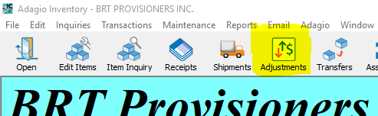
* Entry Type = depends on the situation, but normally “Qty and Cost”
* Direction = Decrease to reverse the entry
* Date = date of the original inventory entry
* Item Number = item to be reversed (same as original entry)
* Location = same as used for the original entry being reversed
* Quantity = amount to be reversed (usually same as original inventory entry)
* Cost = Total Cost (including Freight/Additional Cost) entered in Original Entry
* Reason = note explaining why original entry is being reversed
* Write-off Acct = 2105
* Click OK
* Click POST
* Transactions / Print Adjust Audit List & Print

